- What is the community need and job availability for program graduates? Include the data tables from the Economic Modeling Specialists International (EMSI) data provided by the Office of Institutional Research, Assessment, and Planning.

- The Office of Institutional Research, Assessment, and Planning.

25-2032 | Career/Technical Education Teachers, Secondary School
47-2011 | Boilermakers
47-2151 | Pipelayers
47-2152 | Plumbers, Pipefitters, and Steamfitters
47-2211 | Sheet Metal Workers
47-2221 | Structural Iron and Steel Workers
47-3015 | Helpers--Pipelayers, Plumbers, Pipefitters, and Steamfitters
51-4121 | Welders, Cutters, Solderers, and Brazers
51-4122 | Welding, Soldering, and Brazing Machine Setters, Operators, and Tenders

Regions
Code | Description
6019 | Fresno County, CA
6031 | Kings County, CA
6039 | Madera County, CA
6047 | Merced County, CA
6107 | Tulare County, CA
Timeframe
2016 - 2026
Datarun
2016.3 – QCEW Employees, Non-QCEW Employees, and Self-Employed
9 Occupations in 5 Counties
Occupation Summary for 9 Occupations
5,158 |  | 9.3% |  | $21.05/hr
Jobs (2016) |  | % Change (2016-2026) |  | Median Hourly Earnings
23% below National average |  | Nation: 10.0% |  | Nation: $21.96/hr
Growth
5,158 | 5,639 |  | 481 |  | 9.3%
2016 Jobs | 2026 Jobs |  | Change (2016-2026) |  | % Change (2016-2026)

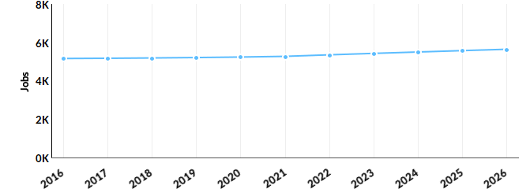
Occupation | 2016 Jobs | 2026 Jobs | Change | % Change
Career/Technical Education Teachers, Secondary School (25-2032) | 278 | 303 | 25 | 9%
Boilermakers (47-2011) | 74 | 84 | 10 | 14%
Pipelayers (47-2151) | 218 | 263 | 45 | 21%
Plumbers, Pipefitters, and Steamfitters (47-2152) | 1,876 | 2,077 | 201 | 11%
Sheet Metal Workers (47-2211) | 487 | 541 | 54 | 11%
Structural Iron and Steel Workers (47-2221) | 292 | 317 | 25 | 9%
Helpers--Pipelayers, Plumbers, Pipefitters, and Steamfitters (47-3015) | 107 | 131 | 24 | 22%
Welders, Cutters, Solderers, and Brazers (51-4121) | 1,637 | 1,750 | 113 | 7%
Welding, Soldering, and Brazing Machine Setters, Operators, and Tenders (51-4122) | 189 | 173 | -16 | -8%

Percentile Earnings
$16.38/hr | $21.05/hr | $25.93/hr
25th Percentile Earnings | Median Earnings | 75th Percentile Earnings
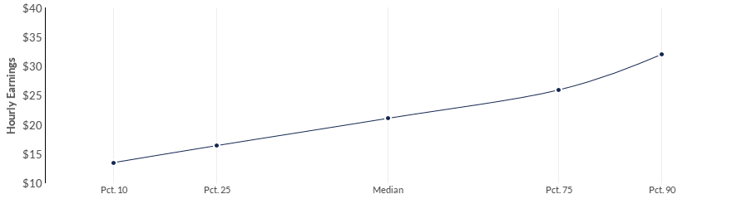
Occupation | 25th Percentile Earnings | Median Earnings | 75th Percentile Earnings
Career/Technical Education Teachers, Secondary School (25-2032) | $26.18 | $33.52 | $40.39
Boilermakers (47-2011) | $22.98 | $27.06 | $31.07
Pipelayers (47-2151) | $13.08 | $15.51 | $19.57
Plumbers, Pipefitters, and Steamfitters (47-2152) | $17.92 | $24.00 | $30.93
Sheet Metal Workers (47-2211) | $16.10 | $21.39 | $27.23
Structural Iron and Steel Workers (47-2221) | $15.66 | $20.36 | $24.73
Helpers--Pipelayers, Plumbers, Pipefitters, and Steamfitters (47-3015) | $12.27 | $13.55 | $16.21
Welders, Cutters, Solderers, and Brazers (51-4121) | $13.96 | $17.29 | $19.94
Welding, Soldering, and Brazing Machine Setters, Operators, and Tenders (51-4122) | $14.07 | $16.30 | $18.50

Regional Trends
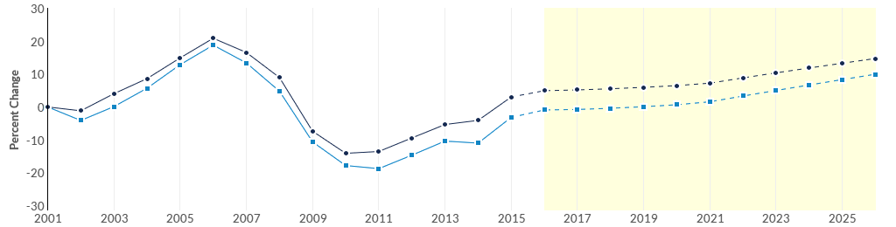
 | Region | 2016 Jobs | 2026 Jobs | Change | % Change
● | Region | 5,158 | 5,639 | 481 | 9.3%
● | Fresno, CA | 2,652 | 2,944 | 292 | 11.0%
● | Fresno County, CA | 2,652 | 2,944 | 292 | 11.0%
Regional Breakdown
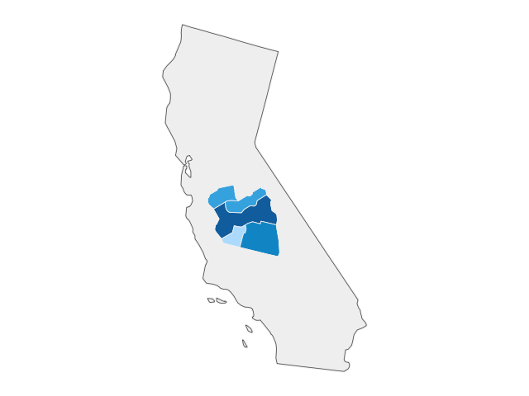

County | 2026 Jobs
Fresno County, CA | 2,944
Tulare County, CA | 1,262
Merced County, CA | 675
Madera County, CA | 507
Kings County, CA | 251

Job Postings Summary
569 | 4 : 1
Unique Postings (Jan 2016 - Aug 2016) | Posting Intensity (Jan 2016 - Aug 2016)
2,341 Total Postings | Regional Average: 6 : 1
There were 2,341 total job postings for your selection from January 2016 to August 2016, of which 569 were unique. These numbers give us a Posting Intensity of 4-to-1, meaning that for every 4 postings there is 1 unique job posting. This is lower than the Posting Intensity for all other occupations and companies in the region (6-to-1), indicating that they may not be trying as hard to hire for this position.
Occupation Gender Breakdown
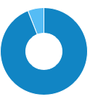
 | Gender | 2016 Jobs | 2016 Percent
● | Males | 4,848 | 94.0%
● | Females | 310 | 6.0%

Occupation Age Breakdown
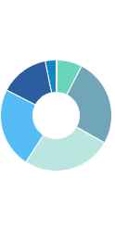
 | Age | 2016 Jobs | 2016 Percent
● | 14-18 | 16 | 0.3%
● | 19-24 | 375 | 7.3%
● | 25-34 | 1,320 | 25.6%
● | 35-44 | 1,337 | 25.9%
● | 45-54 | 1,207 | 23.4%
● | 55-64 | 738 | 14.3%
● | 65+ | 164 | 3.2%
Occupation Race/Ethnicity Breakdown
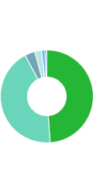
 | Race/Ethnicity |  |  |  | 2016 Jobs |  |  |  | 2016 Percent
● | White |  |  |  | 2,520 |  |  |  | 48.9%
● | Hispanic or Latino |  |  |  | 2,238 |  |  |  | 43.4%
● | Asian |  |  |  | 180 |  |  |  | 3.5%
● | Black or African American |  |  |  | 123 |  |  |  | 2.4%
● | Two or More Races |  |  |  | 59 |  |  |  | 1.1%
● | American Indian or Alaska Native |  |  |  | 28 |  |  |  | 0.5%
● | Native Hawaiian or Other Pacific Islander |  |  |  | 9 |  |  |  | 0.2%
Occupational Programs
6 |  |  | 82 |  |  | 221
Programs (2015) |  |  | Completions (2015) |  |  | Openings (2015)
CIP Code |  | Program |  |  |  |  | Completions (2015)
48.0508 |  | Welding Technology/Welder |  |  |  |  | 82
46.9999 |  | Construction Trades, Other |  |  |  |  | 0
46.0503 |  | Plumbing Technology/Plumber |  |  |  |  | 0
46.0000 |  | Construction Trades, General |  |  |  |  | 0
13.1320 |  | Trade and Industrial Teacher Education |  |  |  |  | 0
Industries Employing 9 Occupations
Industry |  |  |  | Occupation Group Jobs in Industry (2016) |  |  |  | % of Occupation Group in Industry (2016) |  | % of Total Jobs in Industry (2016)
Plumbing, Heating, and Air-Conditioning Contractors |  |  |  | 1,451 |  |  |  | 28.1% |  | 36.2%
Elementary and Secondary Schools (Local Government) |  |  |  | 292 |  |  |  | 5.7% |  | 0.5%
Water and Sewer Line and Related Structures Construction |  |  |  | 259 |  |  |  | 5.0% |  | 14.7%
Commercial and Industrial Machinery and Equipment (except Automotive and Electronic) Repair and Maintenance |  |  |  | 228 |  |  |  | 4.4% |  | 13.4%
Local Government, Excluding Education and Hospitals |  |  |  | 164 |  |  |  | 3.2% |  | 0.5%

Appendix A - Data Sources and Calculations
Location Quotient
Location quotient (LQ) is a way of quantifying how concentrated a particular industry, cluster, occupation, or demographic group is in a region as compared to the nation. It can reveal what makes a particular region unique in comparison to the national average.
Occupation Data
Emsi occupation employment data are based on final Emsi industry data and final Emsi staffing patterns. Wage estimates are based on Occupational Employment Statistics (QCEW and Non-QCEW Employees classes of worker) and the American Community Survey (Self-Employed and Extended Proprietors). Occupational wage estimates also affected by county-level Emsi earnings by industry.
CareerBuilder/Emsi Job Postings
Job postings are collected from various sources and processed/enriched by Careerbuilder to provide information such as standardized company name, occupation, skills, and geography. Emsi performs additional filtering and processing to improve compatibility with Emsi data.
Completers Data
The completers data in this report is taken directly from the national IPEDS database published by the U.S. Department of Education's National Center for Education Statistics.
Institution Data
The institution data in this report is taken directly from the national IPEDS database published by the U.S. Department of Education's National Center for Education Statistics.
State Data Sources
This report uses state data from the following agencies: California Labor Market Information Department

